PURPOSE
To define objectives and procedures in paper tracking or tracking of a sample of HIV positive lost to follow patients in BetterInfo clinics.

SCOPE
This SOP applies to all staff involved in paper tracking of sampled lost to follow patients from HIV care in all BetterInfo sampled clinics.

RESPONSIBILITIES
All personnel involved in tracking of lost to follow from HIV care patients are responsible for complying with the requirements of this SOP. The Study Coordinator (SC) is responsible for ensuring that personnel are trained, training is documented and that personnel are following procedures as outlined.

PROCEDURES

- The late list will be generated by the study team from Electronic Medical Record System (EMRS) also known as SMART CARE. Patients to be included in this list are those who are aged 18 years and above, enrolled in HIV care and have accessed HIV services in the last 2 years regardless of date of enrollment. This also includes patients that are late for their pharmacy appointment or clinical appointment. The list will be generated by the BetterInfo data team.
- NB: this is distinct from the SMART CARE (SC) late lists that are routinely generated by the system and distributed to the sites.
- The late list will be provided to the trackers through the Assistant Study Coordinators (ASCS) in each of the BetterInfo Study sites. Each list for the pilot will contain 20 lost to follow up and at a minimum 160 lost to follow patients for the main study.
- The Tracker will retrieve the files of all patients assigned to him /her by the ASC that are listed as lost to follow up on using the ‘List of Patients to be Tracked’ using the patient’s ID number (ART number) from the registry or filling room.
  - Note that patient files could also be in other areas of the clinic, particularly for temporary storage. The Tracker should check all possible areas where the file might be. If the patient file is not found or the Tracker wants confirmation of the information on the patient file, the Tracker can also work with the Data Associate (DA) at the facility to find the patient in the SC database.
  - If no paper file or chart is found at all, information for file or chart reviewing may be present in SC. In other words, the electronic medical record is a part of “chart” and should be reviewed in this process.
- Purpose of review of patients files
  - Once the list of patients who are lost to follow-up and who will be tracked is identified, file or chart review to (1) confirm lost status (2) obtain information about the identity of patient and (3) obtain information about locator information should be carried out.
  - If the patient is not lost and therefore need not be tracked, this information is recorded in the LTFU questionnaire. If the patient is indeed lost, the identifying and location information abstracted in this SOP is purely for tracking patients and is not “entered” as study data. Trackers should keep a notebook in which to make notes about the patients they seek that contains some of this information below.
  - Patients may be known to have died on file or chart review.
    - This information about death may be recorded in the patient record, but not in the electronic medical record system. Hence the patient appears lost in a computerized query. Patients who are found to have died on file or chart review should have this information and the closest approximation to the death date recorded in the study tracking forms.
  - Patient may have transferred out.
    - For the purposes of this study, we will consider patients to have transferred out only if both (1) an official transfer form is present and (2) there are no visits after the date of transfer indicated in the official transfer form.
    - Informal “transfers” recorded on the patient charts represent a diverse range of “true” patient outcomes and unless accompanied by official documentation, should not be considered an official outcome.
    - Transfers may return and if they come back to the clinic of interest, subsequent missed visits represent loss to follow-up. Therefore, if a patient has a transfer out – even if official – but has recorded clinic visits after that date, the patient is assumed to have re-transferred in and as such should be considered lost to follow-up if they meet the definition.
  - Patients may be in care
    - Patient may be in care at the time of chart review because there has been time elapsed since the list of lost patients was generated and the date that the charts are reviewed. In these cases, patients will not be tracked. The date of return, however, should be recorded on the loss to follow-up questionnaire in the appropriate place.
    - Patients may also be in care simply because a visit that truly transpired and which is recorded in the paper medical records was missed in the electronic medical records. These dates should also be recorded in the questionnaire.
  - In rare circumstances, the patient will be found to not be in the Current Clinical Population (CCP).
    - In these cases the patient should not be tracked and this outcome should be recorded in the Lost to Follow-Up (LTFU) Questionnaire.
- Chart review to obtain identifying information
  - Information to confirm the identity of the patient that may be present in the paper chart. This information should be recorded by trackers in their working notebooks so and used to confirm that encounters in the field do actually represent the patient of interest. This information includes:
  - Name: The full name of the patients is the most important identifier but in some settings nicknames are more commonly used in the community and should be used by the tracker if this information is available at the clinic chart.
  - Clinic identifiers: Patients may often have multiple clinic identifiers (such as TB clinic, maternal-child health, etc.) and if the patient has clinic papers at home, recording this information will provide additional and strong evidence that the right patient has been identified.
  - Age: Patients with the same name can be distinguished by age if the difference in age is large. We will ask this information to be abstracted (but not recorded as study data) to facilitate the tracking process.
  - Height: Height is a characteristic of adults that does not change much over time. In field experience, patients with the same name can occasionally be distinguished by height.
  - Occupation: Occupation can be used to identify patients.
  - Clinical information: Details of someone’s treatment history can be, if a particular tracking team finds useful, be an additional adjunct. Variables such as how long the patient has been enrolled, the length of time on ART, etc. may be useful as well.
  - Cultural characteristics: Religion, tribe and primary language may be useful to use in identifying patients where there is variability in these characteristics in the clinic population.
- File/Chart review to obtain locator information
  - Locator information is needed to find the patients in the field. Locator information is comprised of geographic / residence information as well as social information about contacts which can help locates the patient.
  - Geographical information
    - Geographical information about the residence itself (the bounded structure in which the patient sleeps) or the location (the geographic area of the residence) are crucial pieces of information for tracking. Sometimes maps are drawn in paper charts: copies or reproductions of the maps can be used to track patients.
    - Geographical information about other places the patient frequents other than the residence is sometimes available and may be useful as well. This includes place of work, a particular location of socializing, or a sit where important past medical information was obtained (such as a VCT site). These sites may be places to look for the patient.
  - Obtain social contact information
    - Tracking is a social as well as a geographic activity. Information about the patient’s contact should also be obtained as part of the locator information. This includes treatment supporter, treatment supporter’s address and telephone numbers if available, spouses and other people who the patient knows. Some clinics record “family identifiers” that can be used to link other members of the family.
    - Patient Information Form should also list any persons to whom the patient has disclosed her/his status such as a buddy or other individual(s). Since these individuals are likely to yield highest informants as well as the fact that the patients’ medical information can be discussed with these informants.
- Complete ‘Patient Information Form’ (see FO9 -00 Better Info Locator Form in Appendix 1) based on information from the file. Remember to check for locator information throughout the file, not only on the locator form and to record ‘buddy’ information. Complete ‘Module Section A’.
- For all patients with a known outcome, the Tracker will take those patient files to the facility In-Charge and the Data Associate (DA). The Tracker will have the In-Charge or DA sign off on ‘Patient Information Form’.
- Files should be returned to data and registry departments respectively for updating and refiling.
- Tracker will submit list of all patients for whom tracking will be attempted with copied locator information using study form (FO9-00 Better Info Locator Form) to the ASC after all 20 files are paper tracked or no later than 3 days after paper tracking begins.
- Tracker takes patients assigned by the ASC and continues by following procedures in SOP 1.10 ‘Phone Tracking’

APPENDICES:
Figure 1: Summary of workflow in chart tracking. In short, the process of paper tracking or chart tracking involves three decisions. First, we use information in the file that is not necessarily in SC to decide if the patient is appropriate for tracking. Reasons patients might not be confirmed to be appropriate for tracking are if the patient has died, the patient has transferred, the patient is not lost, the patient is not in the CCP. Second, if the appropriateness of tracking is confirmed, the file or chart review is to ensure that tracking is possible. This involves evaluation of locator and identifying information. If the answer to these questions is both yes, then the tracker should document in the tracking notebook information needed to find the patient and start active phone tracking. If the answer to either of these question is no, then the reasons should be documented as per the LTFU chart tracking form.
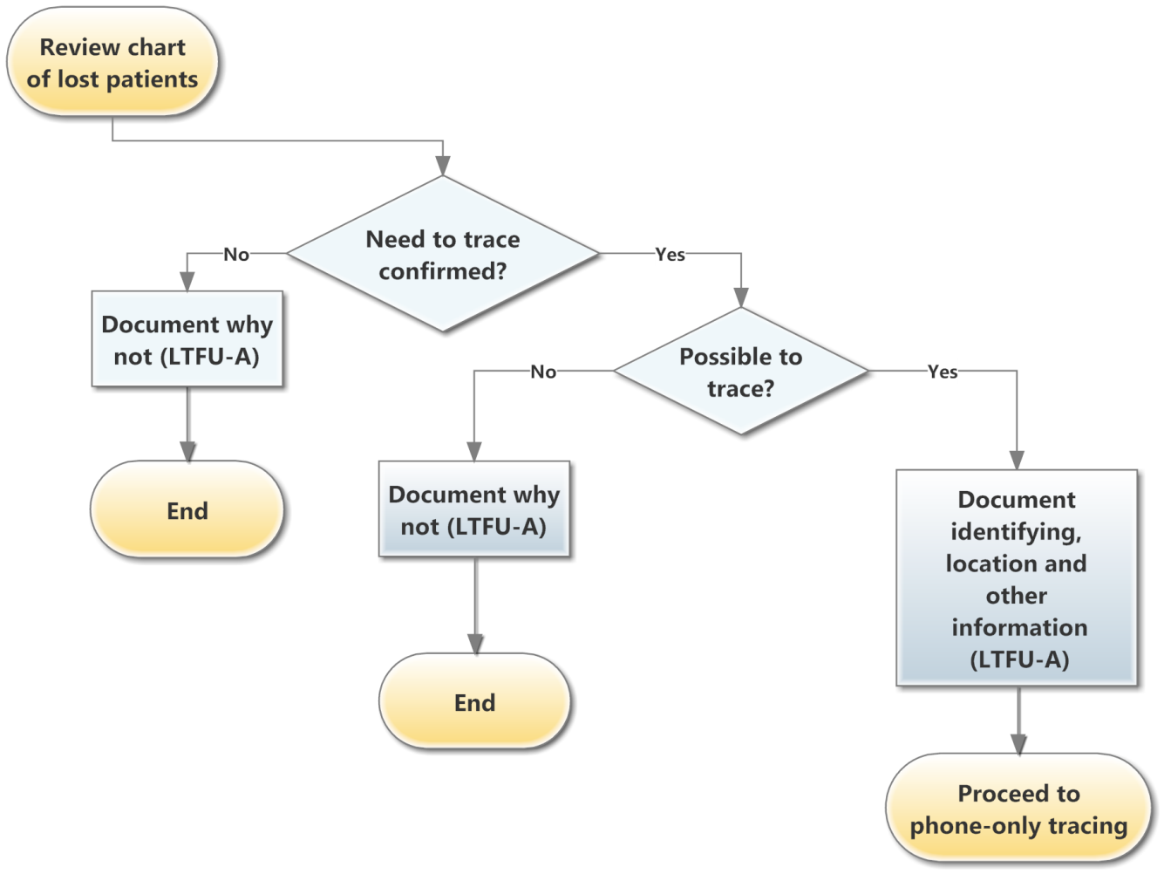

Appendix 1: Locator Form (F09-00)
Patient Details
ID#: | b |  | c | Marital status:
Name:
Name goes by in community:
Occupation:
Employer/Workplace:

Contact Details and Address
Phone #:
House/Plot #:
Street Name:
Township/Compound
Village:
Chief:

Treatment Supporters' Details
a. | Name | b. | Relation to Patient | c. | Phone/Contact Info | d. | Lives with Patient (Y/N)
1
2
3
4
5

Emergency Contact Details
Name:
Relation to Patient:
Phone #:
House/Plot #:
Street Name:
Township/Compound:
Village:
Chief:

Detailed directions and map on how to reach the patients' house

REFERENCES:

Better Info Protocol Version 1.1 and SOP Patient Tracking Guidelines: The Community and Data Team, CIDRZ, CDC, Ministry of Health and PEPFAR.
APPENDICES: Nil
ABBREVIATIONS AND ACRONYMS
CIDRZ Centre for Infectious Disease Research in Zambia
MOH Ministry of Health
REVISION HISTORY

SOP # | Effective Date | Supersedes | Review Date | Change/Comments

